WS 2025/26

Lab course: Human Robot Interaction

Task 6: Object Recognition

Chair of Autonomous Systems and Mechatronics
Friedrich-Alexander-Universität Erlangen-Nürnberg

TEAM 1 :
Velayudhan Aravindakshan - ju08rufe
Akhilan David Karthikeyan - ug39owys
Wei Zhang - jo07wuwe

Exercise 1

- Based on the understanding from the sources
Precision measures the proportion of correctly identified positive detections out of all positive detections made.
Recall measures the proportion of actual positives that were correctly identified.
Accuracy is the ratio of correct predictions to the total number of input samples.
- Freezing layers is used to utilize a pretrained network while decreasing training time. By freezing the general layers close to the input, only the layers closer to the output are trained to make decisions on specific labels, which is efficient because initial layers filter images on a broader, more general level.
- Transfer learning should be used when there is not enough data available to train a whole network from scratch. It involves retraining a network that has already been pretrained on a similar dataset to adapt it to new data.
- Data augmentation methods include scaling, rotating, or changing the color of existing training images. These techniques allow for the generation of new training data from existing data while ensuring the object remains recognizable.

Exercise 2

The segmentation happened with the input image and was stored in the root folder of the script/run/detect/exp (in my case /home/hri-lab/Desktop/ros/runs/detect/exp).
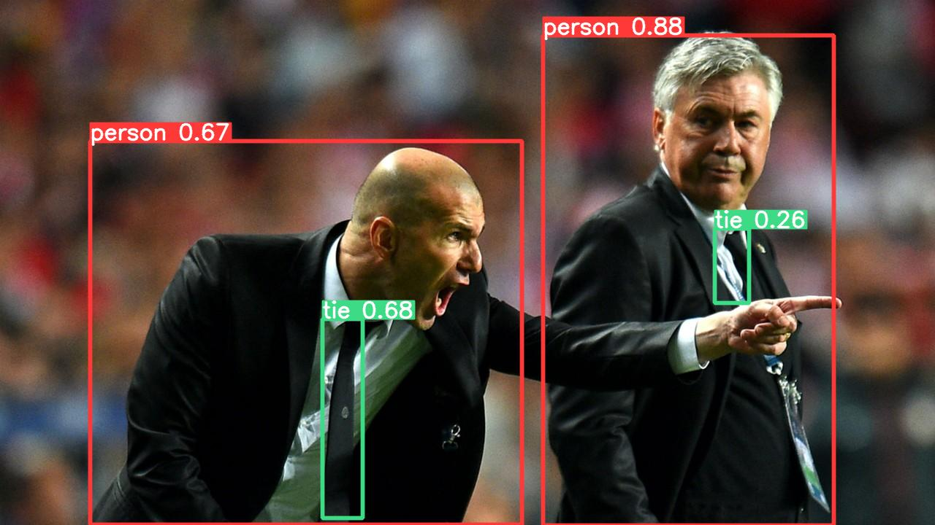

Exercise 3
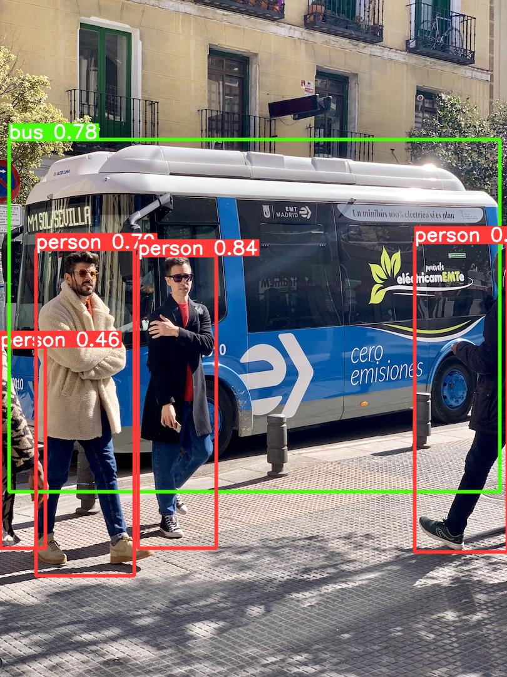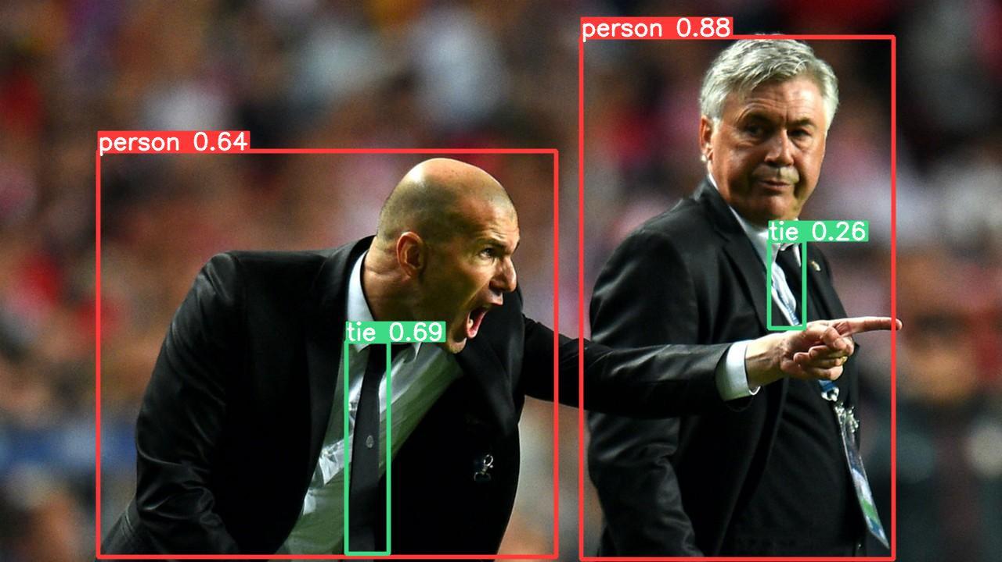

50 epochs
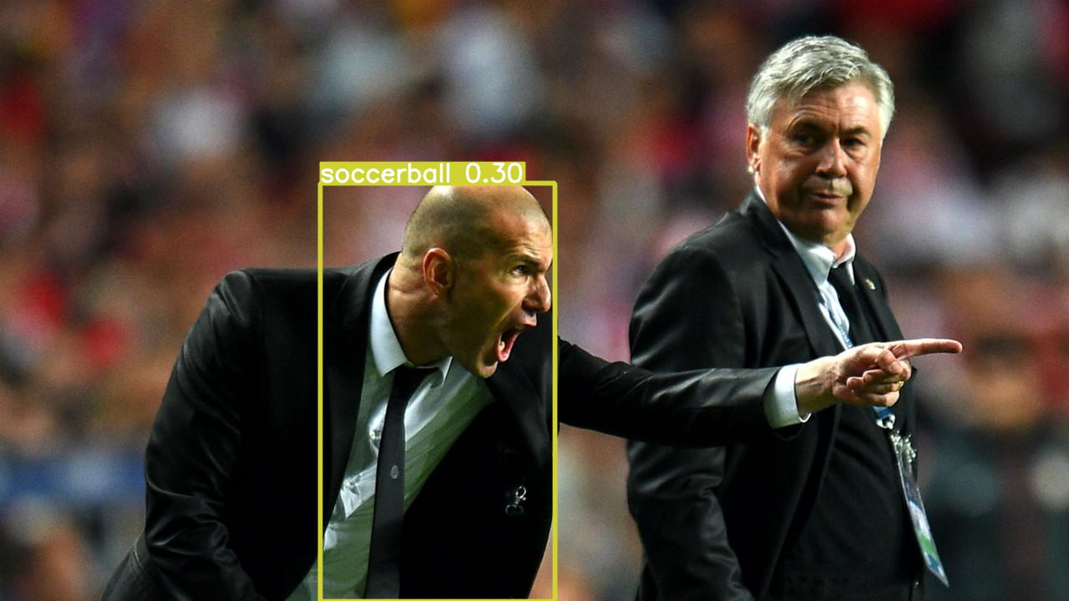
100 epochs
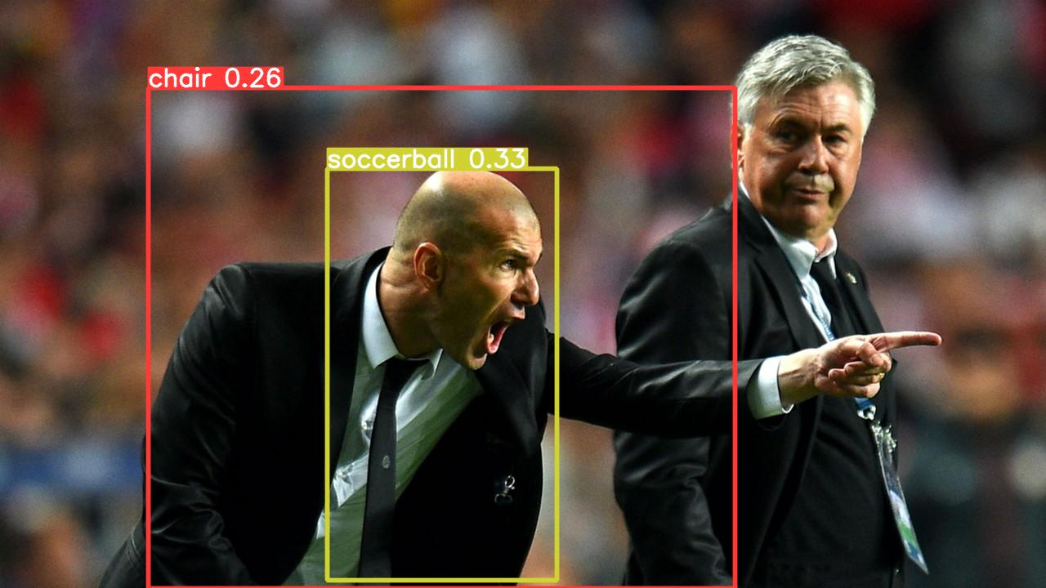
500 epochs


c. Pre‑trained model: person, tie are recognized correctly.
- 50 epochs: soccer appears but it’s wrong.
- 100 epochs: recognition unstable.
- 500 epochs: no objects detected.
d. The pre‑trained model detects COCO categories consistently. The 50‑epoch model begins to adapt to the custom categories but weakly and little unstable. The 100‑epoch model is unstable. The 500‑epoch model fails to detect anything.
e. The pre‑trained model performs better because it was trained on a large dataset (COCO) with many categories, giving strong generalization. The retrained models had limited data, so they either underfit (50/100 epochs) or overfit (500 epochs).
f. The pre‑trained model outputs COCO classes (e.g., person, tie). The further trained models output the experiment’s custom classes (e.g., soccerball, mug, bottle, scissors).

Exercise 4
Using the labelling python script and using the user interface the sample pictures were correctly segmented with the objects manually.

Exercise 5
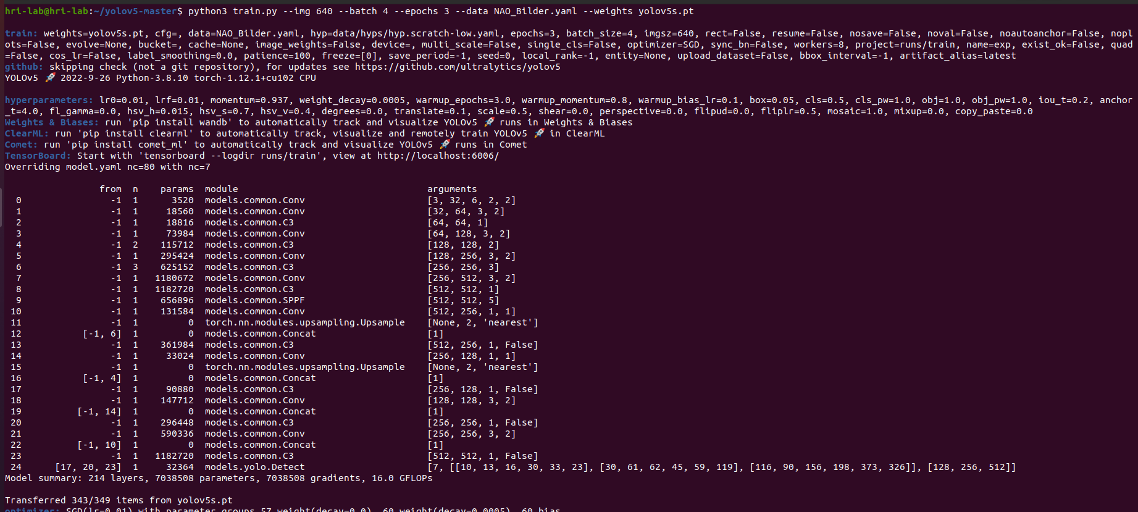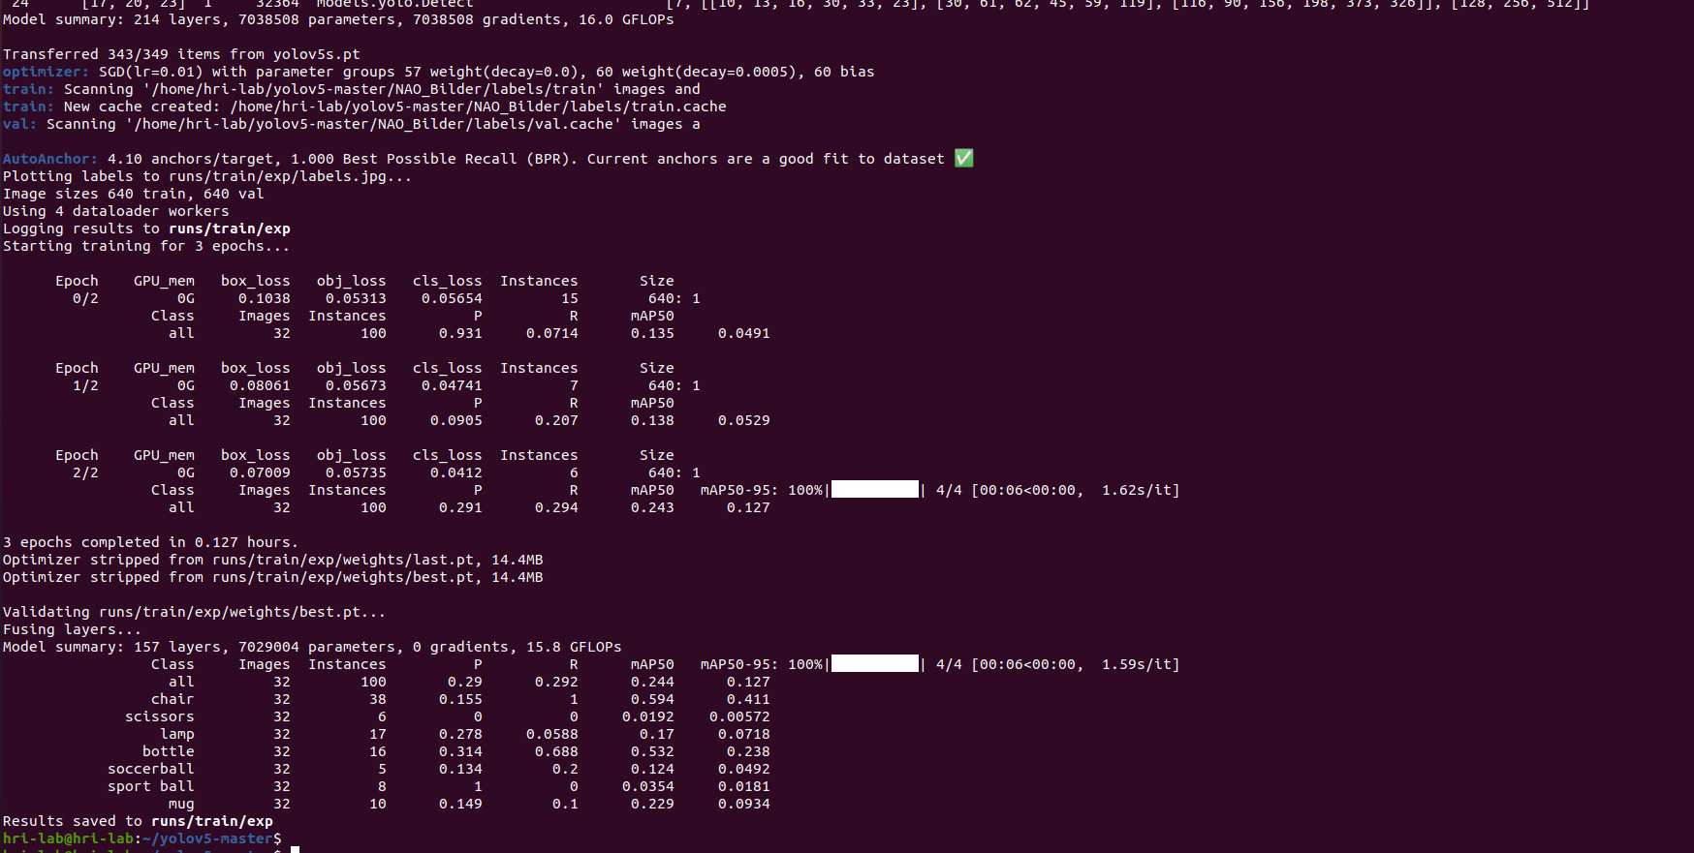
Yes, the training was successful in a technical sense because the script completed and generated new model weights (best.pt). However, 3 epochs is a very short duration; while you should see a slight decrease in loss, the model will not yet be highly accurate for complex detections. This run is primarily to verify that your labeling and folder structure are correct before doing longer training.

Exercise 6
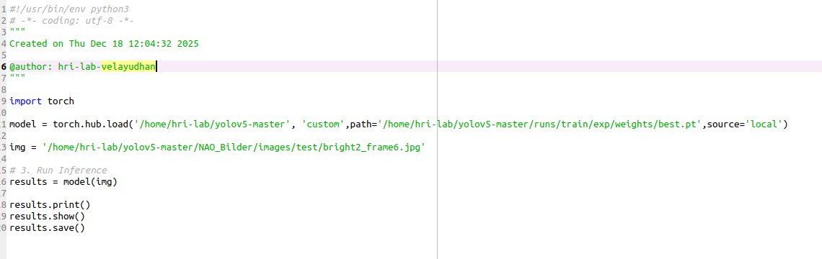

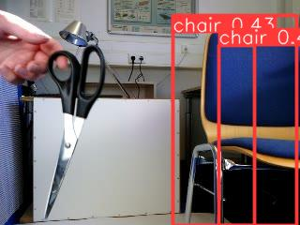
With the training done with 3 epochs the missing detection for scissors is expected. This is just a sanity check, however if the test would have been computed with the epochs of 500 the test result would have been more satisfactory.

